**Protect your bread and butter**

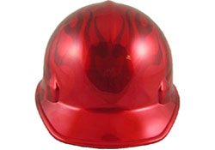

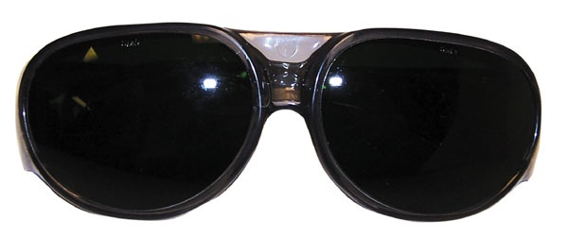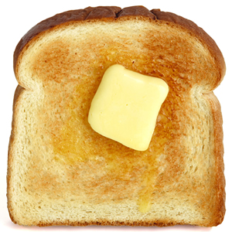

***Always wear Your***

***Safety Glasses and***

***Proper protective gear***

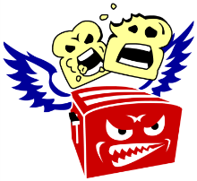-From your friendly Neighborhood Flying Toasters