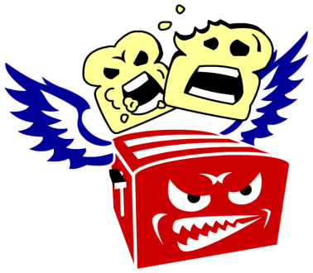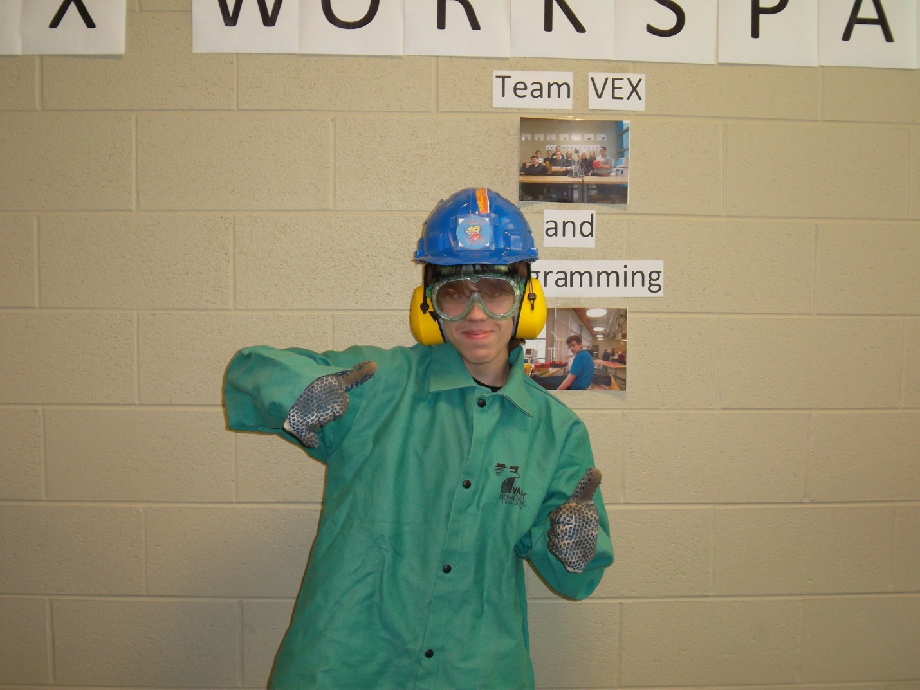

**Steel Toed Shoes**: to protect your feet from falling objects or hammers.

**Positive Attitude**: a can do attitude will keep you alert and thinking forward, reducing the chance of injury.

**Tie Back Loose Clothing**: to prevent from being wound up or torn in machinery or caught in other spinning objects.

**Gloves**: to protect your hands from being cut while utilizing sharp objects.

**Protective Hearing Device**: to protect your ears from loud and potentially damaging sounds of machinery (or from Chaz’s scream). Use of ear phones with this protective gear negates safety benefit.

**Helmet**: to protect the cranial cavity when operating large and/or dangerous machinery, or when objects are falling around you.

Safety Rules

**Safety Glasses**: to protect your eyes from flying debris and other hazardous materials.